**ASSIGNMENT**

**1) What is Software Testing?**

* It is activity where we check whether the actual requirement is equal to the expected requirement.
* It makes the software **DEFECT FREE, BUG FREE** and **ERROR FREE**.
* It checks any gaps, missing requirements and ERROR in contrary to the expected requirement.
* It checks the **CORRECTNESS, COMPLETENESS** and **QUALITY** of the software.

**2) What is SRS**

**Software Requirement Specification**

**3) What is SDLC**

* **SDLC = SOFTWARE DEVELOPMENT LIFE CYCLE**
* A software development life cycle is essentially a series of steps, or phase, that provide a model for the development and lifecycle management of an application or piece of software.

**4) What is agile methodology?**

* It is a combination iterative and increment model.
* It divides the software into small incremental build, this build are provided in iterations, that means the big projects are divided into small chunks(iterations).
* Each iteration last about one to three weeks.
* Each iteration involves all the team members working simultaneously on areas like planning, requirement analysis, design, coding, unit testing and acceptance testing.
* At the end of the iteration the working product is displayed to the customer or the important stake holder and it is released in the market.
* After the release we check for the feedback of the deployed software.
* If any enhancement is needed in the project then it’s done and it’s re-released.

**Advantage of agile method:**

1. **Frequent delivery**
2. **Face to face communication with the customer**
3. **Less time**
4. **Adaptability**

**Disadvantage of agile method:**

1. **Less documentation**
2. **Maintenance problem**
3. **What is OOPS**

* Identifying objects and assigning responsibilities to these objects.
* Objects communicate to other objects by sending messages.
* Messages are received by the methods.
* An object is like a black box.
* The Internal details are hidden.
* Class blueprint of object.

1. **Write basic concepts of oops**

* 1) Class
* 2) Object
* 3) Encapsulation
* 4) Inheritance
* 5) Polymorphism

1. Over ridding
2. Over loading

* 6) Abstraction

1. **What is object**

* Object gives permission to access the functionality of class.

1. **What is class**

* Class is collection of data member and function.

1. **What is encapsulation**

* Wrapping of data.

1. **What is inheritance**

* Creating a class from an existing class.

1. **What is polymorphism**

* One name multiple form.

1. **Over ridding:** Function with same name and same parameter.

**Ex. Void calc ()**

**{**

**a+b**

**}**

**Void calc ()**

**{**

**a-b**

**}**

1. **Over loading:** Function with same name and different parameter.

**Ex. Void calc (a, b)**

**{**

**a+b**

**}**

**Void calc (x, y)**

**{**

**x-y**

**}**

1. **Write SDLC phases with basic introduction**

* **1) Requirements collection/ gathering:** Establish customer needs
* **2) Analysis:** Model and specify the requirements - **“what”**
* **3) Design:** Model and specify a solution – **“why”**
* **4) Implementation:** Construct a solution in software(coding)
* **5) Testing:** Validate the solution against the requirements
* **6) Maintenance:** Repair defects and adopt the solution to the new requirements

1. **Explain phases of the waterfall model**

* Requirements must be “frozen” to early in the life cycle
* Requirements are “validated too late”
* **Application (what to use?)**
* Requirements are very well documented, clear and fixed.
* Product definition is stable.
* Technology is understood and is not dynamic.
* There are no ambiguous requirement.
* The project is short.
* **Pros (why waterfall model)**
* Simple and easy to understand and use.
* Easy to manage due to the rigidity of the model. Each phase has specific deliverables and a review process.
* Phases are processed and completed one at a time.
* Works well for smaller projects where requirements are very wll understood.
* Process and results are well documented.
* Clearly defined stages.
* Easy to arrange tasks.
* **Cons (why not waterfall model)**
* No working software is produced until late during the life cycle.
* High amounts of risk and uncertainty.
* Not a good model of complex and object-oriented projects.
* Poor model for long and ongoing projects.
* Cannot accommodate changing requirements.

1. **Write phase of spiral model?**

* **Pros (why it works)**
* Changing requirements can be accommodated.
* Requirements can be captured more accurately.
* Users see the system early.
* Development can be divided into smaller parts and more risky parts can be developed earlier which helps better risk management.
* **Cons (why it doesn’t work)**
* Management is more complex.
* End of project may not be known early.
* Process is complex.
* Spiral may go indefinitely.
* Large number of intermediate stages requires excessive documentation.

1. **What is agile methodology?**

* It is a combination iterative and increment model.
* It divides the software into small incremental build, this build are provided in iterations, that means the big projects are divided into small chunks(iterations).
* Each iteration last about one to three weeks.
* Each iteration involves all the team members working simultaneously on areas like planning, coding, unit testing and acceptance testing.
* At the end of the iteration the working product is displayed to the customer or the important stake holder and it is released in the market.
* After the release we check for the feedback of the deployed software.
* If any enhancement is needed in the project them it’s done and it’s re-released.

1. **Write agile manifesto principles?**
2. Satisfy customers through early and continuous delivery
3. Welcome changing requirements even late in the project
4. Deliver value frequently
5. Break the silos of your project
6. Build projects around motivated individuals
7. The most effective way of communication is face to face
8. Working software is the primary measure of progress
9. Maintain a sustainable working pace
10. Continuous excellence enhance agility
11. Simplicity is essential
12. Self-organizing teams generate most value
13. Regularly reflect and adjust your way of work to boost effectiveness
14. **Explain working methodology of agile model and also write pros and cons**

* **Advantage of agile method**

1. Frequent delivery
2. Face to face communication with the customer
3. Less time
4. Adaptability

* **Disadvantage of agile method**

1. Less documentation
2. Maintenance problem

**18)** **Draw Use case on Online book shopping**

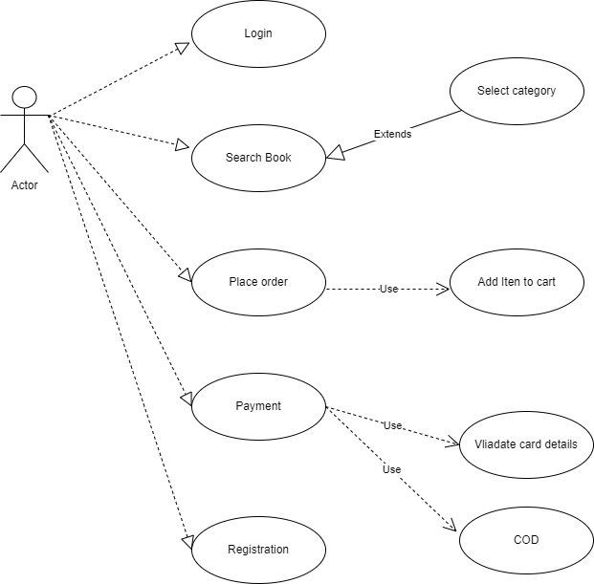

**19)** **Draw Use case on online bill payment system (Paytm)**

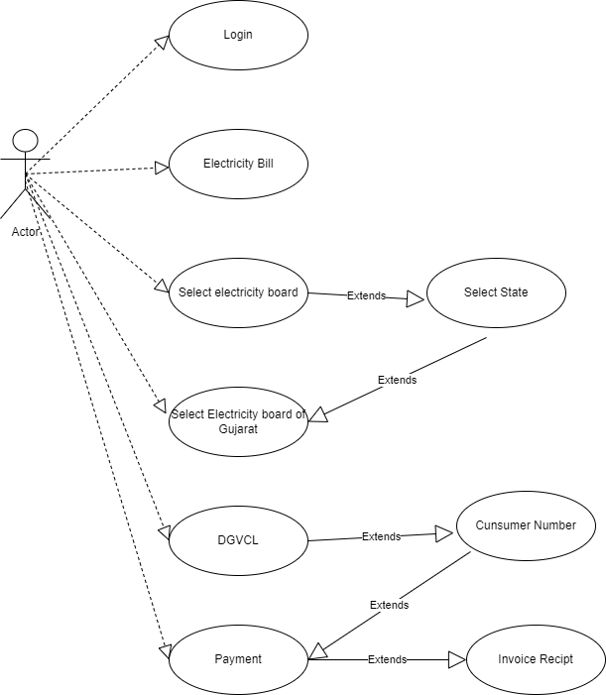

**20)** **Draw use case on Online shopping product using COD.**

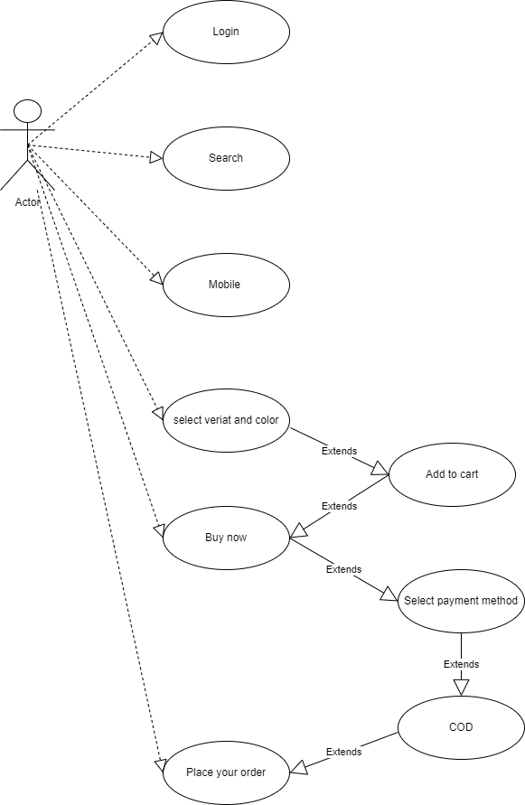

**21)** **Draw use case on Online shopping product using payment gateway.**

